Template instructions are written in blue. Delete all blue text (including this instruction) and ensure your text is black. When text is required to be inserted within <brackets>, ensure the < > are deleted.

This Agreement sets out the teamwork expectations of Team <YourProjectID> comprised of the following members:

Mansour Saud Alsaadi
Aththanayaka Mudiyanselage Sandun Sapumal Bandara Karunawardhana
Senith Nanila Gamathige
Salvino Saji Henry

1 PURPOSE OF THE AGREEMENT
This contract outlines our expectations of each other and the team as a whole for the ENG 3005 Research Project. This contract represents an agreement that will apply throughout the duration of the course.

2 TEAM OBJECTIVES
The team’s primary objective is to work together effectively to deliver the teamwork components of the course, including the literature review, presentation, and project plan. Additional team objectives are listed below.

The main aim of the team is to jointly study the historical records of rainfall over a long period in Adelaide Airport and come up with a forecast model based on time-series techniques. The team will see to it that every member is informed of their duties, and there is effective team communication, and that all the project elements are achieved on time, such as the literature review, data analysis, presentation, and the final report. The team will be concentrated on using R Studio to perform statistical and analytical procedures, so that the results will be accurate and properly organized, and understand the findings in the context of engineering. The team hopes to improve their teamwork effectiveness so that every individual will make contributions towards the success of the project.

3 WORKLOAD AND PERFORMANCE EXPECTATIONS

3.1 Defining equal contribution
As highlighted in the Course Outline, each student is expected to contribute equally to each teamwork component of the course. The team’s definition of ‘equal contribution’ and how it will be measured are as follows.

All members of the team should be involved in all major areas of the project, such as data collection, R Studio analysis, literature analysis, report writing, and presentation planning. This is a term used to refer to equal contribution. Everyone will have some roles assigned, but everyone will be required to engage in discussions, critique the work of peers, and have an overall understanding of the project.

Contributions will be evaluated based on how well you complete tasks on time, the degree of meeting attendance, the quality of work done, and the level of support in making decisions. To keep track of the progress of each of us, we will also be issuing regular progress reports and factoring in peer feedback to be fair to all. The problems with the individual inputs will be discussed by the team members to guarantee the responsibility and fair participation of all team members.

3.2 Workload expectation
The team's expectations of (1) the workload that each team member will put into the course and (2) how the workload will be logged during the course are:

Each team member will be expected to make equal and regular contributions to every one of the projects. The weekly meetings will evaluate the workload carried out by a team leader and a note-taker who will record the workload and store it at the Project File Repository. The individual contributions would be tracked through the version control and shared documents to ensure transparency and accountability.

3.3 Performance expectation
The expectations each team member has of the team’s performance (grade bracket the team is aiming to achieve, desired quality of team deliverables) are as follows.

The goal of the team is to perform excellently in the project to attain a Distinction or High Distinction grade. In order to meet this criterion, each of the deliverables, such as the literature review, data analysis, presentation, and final report, will be carried out with a focus on technical competence, clarity, and accuracy. The team expects every submission to reflect a thorough understanding of statistical analysis and time-series modeling, both in terms of properly structured R output as well as proper interpretation of the findings. All will be professionally written, having a logical structure, powerful graphics, and a strong connection to practical engineering usage. The group expects that each individual will deliver his or her duties on time, interact with each other, and work as a team in order to achieve high academic quality in the entire project.

3.4 Barriers to achieving team objectives
The team acknowledges that all teams face barriers to achieving team objectives, such as work commitments, balancing schedules, or family commitments, and that potential barriers must be identified and planned for. Potential barriers that may hinder team progress and how they will be managed are outlined below.

The team recognizes that some of the possible challenges are opposing schedules, unequal involvement, technical challenges, and communication issues. Management will be achieved through frequent meetings, providing clear task delegation, internal deadlines, accountability among peers, as well as, using shared communication systems. The technical issues will be addressed with the help of teamwork and seeking other support as needed, which will ensure consistent progress towards the objectives of the project.

3.5 Scope/workload changes
The team acknowledges that the scope of work required to complete an assignment might change, for example as a result of certain tasks taking longer or being more difficult than initially expected. Other unforeseen events, such as a team member becoming ill, may impact the ability of the team to achieve deliverables. The team will address any unforeseen changes in the following way.

The team is aware that the scope of work and workload can change due to unexpected issues, such as increased duration of work, increased volume of information processing, or personal situations that can affect team members. The members will utilize the flexible and adaptive strategy through the evaluation of the progress regularly and changing the project plan according to the situational need. Work can be redistributed among the team members in order to ensure that they meet their deadlines, with priority given to those components of the project that are critical. In times where one member of the team is temporarily handicapped by illness or other commitments, the rest will provide support and ensure that the job continues. The team will support open communication and frequent check-in sessions with the team to timely detect the flaws and implement solutions. The team will handle the variations in workloads adequately by taking necessary steps and responding in a flexible manner, thereby delivering quality and record time deliverables.

4 MEETINGS
The team will manage Advisor Meetings (AM) and Team Meetings (TM) as follows.

meeting frequency
AM: The team will hold advisor meetings as scheduled by the course coordinator or by achievement of a major project milestone (usually every 2-3 weeks or as needed).

TM: Team meeting will happen once every week on a compulsory basis and twice a week according to the project findings.

meeting times
AM: Advisor meetings will be held at the specified time that is determined by course coordinator or agreed upon with the advisor.

TM: Weekly meetings will be held as scheduled/as agreed by the team, provided everyone in the team is available.

Agenda preparation and distribution: Ahead of every meeting, the chairperson will prepare a meeting agenda that will outline key discussion points, progress reports, and tasks to be completed. All the members of the team will be informed of the agenda beforehand through the communication medium that will be selected (e.g., shared drive or message group).

Minute taker rotation and role: This role will be rotated on a weekly basis to ensure equal participation. The individual is responsible for keeping track of the meeting time and making sure all points are discussed during the group meeting

chairperson rotation and role: This role will be carried out by one individual unless there is a situation that calls for a rotation to be done among other team members. The chairperson will be in charge of meeting agendas, facilitating discussions, ensuring participation of the other team members, and ensuring the productivity of the meeting

Note-taking: In addition to the official minutes, some other important notes, updates, and decisions will be thoroughly archived and tracked in the Project File Repository. This will ensure transparency and serve as a point of reference when monitoring project progress.

Apologies for absence from meetings and workshops: The members should be present during regular meetings and workshops, and in case a member is not able to be present, they should provide an apology in advance through a justified communication channel. The missing member should review the records of the meeting, absorb the missing discussions, and complete the task identified within the agreed time. Constant non-attendance without a valid reason can be addressed by the team, and in justifiable cases, the individual can be reported to the course coordinator to initiate some level of responsibility and justification in keeping the team conscious.

5 COMMUNICATION
The team agrees to use the following communication modes for team communication taking into account the recipient and purpose of the communication.

Recipient/s | Purpose | Mode/s
Course coordinator | Queries and clarifications | Microsoft teams
 | Feedback | Email
All team members | Weekly meetings and agenda | Microsoft teams
 | Task allocation
 | General updates
 | File sharing
 | Coordination

6 RECORD KEEPING
In order to fulfil the requirements of the Project Monitoring and Control assignment, team members accept the following responsibilities in relation to regularly updating the Project File Repository.

Each individual in the team should regularly update their Project File Repository with their work, such as code, data, and drafts of their reports. To ensure accountability and transparency, files will be organized and labeled systematically, with the meeting notes and decisions recorded to make the collaboration effective.

7 DISPUTE RESOLUTION

7.1 Dispute avoidance and minor disputes
The team will support a team climate that will minimize the likelihood of disputes among the team, and agree on the following methods for resolving minor disputes within the team.

Openness in communication and mutual respect will guide the team in alleviating conflicts. Minor conflicts are going to be solved in a matter of personal communication and, potentially, group conversations. The course organizer will also be approached in case an impartial solution can be reached by an internal resolution, and if it is impossible.

7.2 Dispute escalation
Any disputes that cannot be resolved within the team will be brought to the attention of the Course Coordinator. While acknowledging the final decision is at the ultimate discretion of the Course Coordinator, the team would like the Course Coordinator to take into account the team’s recommendation that disputes be addressed in the following manner.

Disorders that may not be dealt with within the organization shall be addressed with the Course Coordinator. The team proposes that disputes be solved rationally and fairly, although the final verdict would be made by the Course Coordinator. Before the escalation, the team will document the problem, describe the character of the dispute, the steps taken to resolve it, and the opinions of all those present.

Once the problem becomes too serious, all the relevant information will be delivered openly and objectively to ensure openness. In deciding who to grant the award, the team expects the Course Coordinator to take into consideration the efforts of every member, compliance with agreed-upon duties, communication initiatives, and evidence of participation. The team manages to promote a balanced, neutral, and preliminary settlement strategy focused on keeping academic integrity intact and promoting the growth of the projects. Everybody agrees to respect and receive the final decision made by the Course Coordinator.

8 ACKNOWLEDGEMENTS
We acknowledge the following:
 | Initials of each team member
8.1 The completed sections in this contract are binding on each of the team members and will be referred to by the Course Coordinator in the event of any dispute among team members. | MA |  | SH
 | SA
 | SG
8.2 The expectation is that each student contributes equally to the teamwork components of the course. In the eventuality that this does not occur, students may recommend uneven assessment across team members as part of the Project Contribution document; however, determination of group mark allocations will be at the discretion of the Course Coordinator. | MA |  | SH
 | SA
 | SG
8.3 Where there is evidence that a team member misrepresents their contribution or the contribution of other team members to any assignment, the Academic Integrity Policy may be applied (see the Course Outline for further details). | MA |  | SH
 | SA
 | SG
8.4 Academic Integrity is taken extremely seriously by the University of Adelaide, and current and previous year assignments have been recorded in the University’s plagiarism detection software (see the Course Outline for further details). | MA |  | SH
 | SA
 | SG

SIGNATURES
Each team member is expected to have contributed to this agreement. If one or more members cannot agree, then the team must discuss this with the Course Coordinator at the earliest possible opportunity.

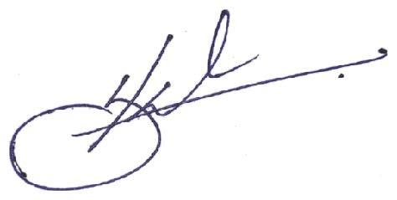
Team Member 1 Team Member 2


Signature: __________________________ Signature: ___________________________

Name: Senith Nanila Gamathige Name: Sandun Aththanayaka Mudiyanselage

Date: 22/03/2026 Date: 22/03/2026

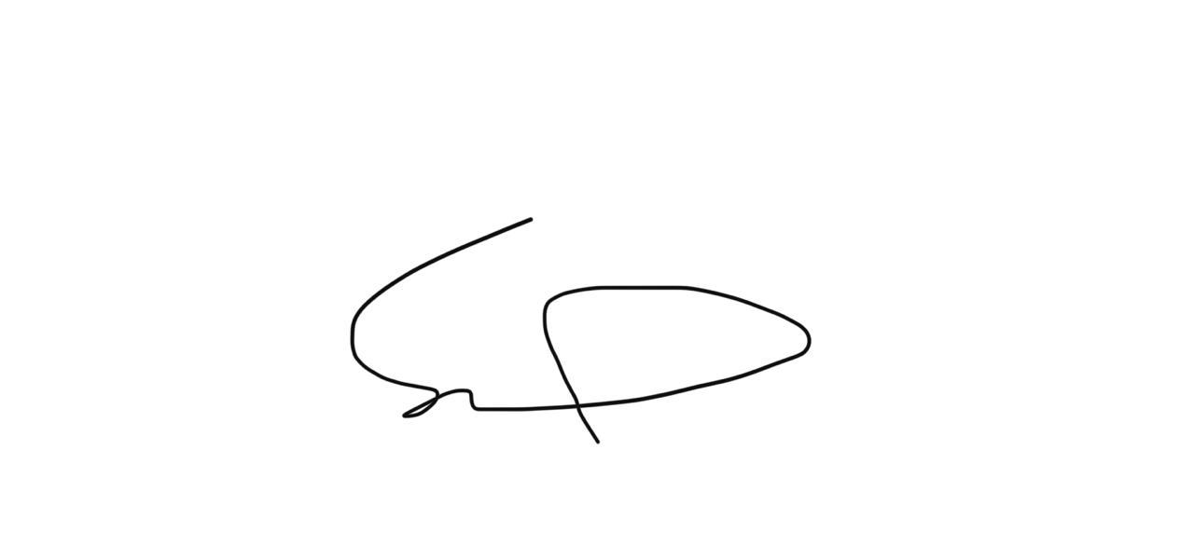
Team Member 3 Team Member 4
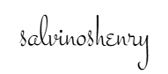

Signature: ___________________________ Signature: ___________________________

Name: Mansour Saud Alsaadi Name: Salvino Saji Henry

Date: 22/03/2026 Date: 22/03/2026

